Tracking Accountability in Government Grants System (TAGGS)
User Guide
February 2024
Contents
1. Purpose 3
2. Getting Started 3
2.1 About TAGGS 3
2.2 Data Dictionary 3
2.3 FAQ 4
2.4 Site Map 5
3. Search Capabilities 6
3.1 Search Overview 6
3.2 Award Search 8
3.3 Recipient Search 10
3.4 Site Search 13
3.5 Advanced Search 16
4. Report Capabilities 20
4.1 Report Overview 20

1. Purpose

The Tracking Accountability in Government Grants System (TAGGS) is a database of grants awarded by the Department of Health and Human Services (HHS). This document outlines the steps for using the search capabilities within the TAGGS public website. It offers an overview of essential search pages and reports within TAGGS, which are useful to support data queries. The document’s purpose is to empower users with the skills to navigate TAGGS confidently and extract data effectively.

2. Getting Started

The TAGGS homepage is accessible via this URL: https://taggs.hhs.gov/.

2.1 About TAGGS

To gain further insight into TAGGS, click on the “About” tab located at the top right corner of the page.

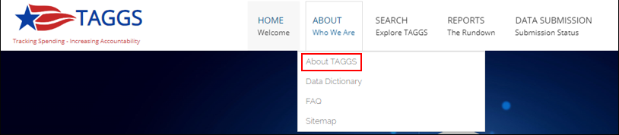

Select “About TAGGS” to access comprehensive background information, including details on TAGGS’ methodology for data collection and instructions on locating specific data: https://taggs.hhs.gov/About.

2.2 Data Dictionary

To explore further details about the data elements within TAGGS and how they are defined, navigate to the “Data Dictionary” located within the “About” tab: https://taggs.hhs.gov/About/Data_Dictionary.

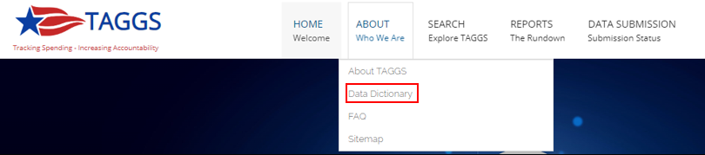

The Data Dictionary features full search functionalities, allowing users to directly search for desired data elements using the toolbar.

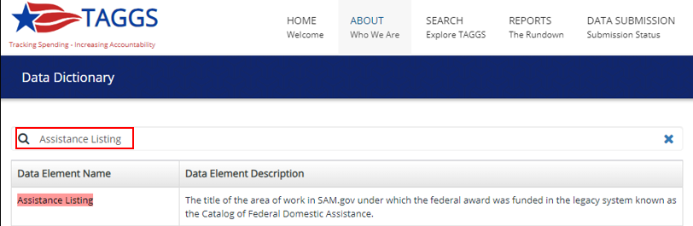

2.3 FAQ

For frequently asked questions regarding TAGGS, data quality, and overall general information, visit the “FAQ” page under the “About” tab: https://taggs.hhs.gov/About/FAQs.

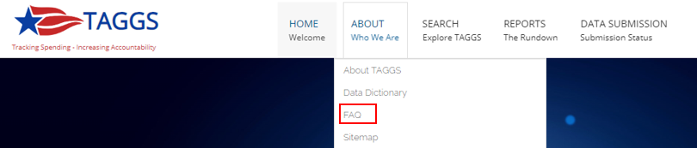

The FAQ features full search functionalities, allowing users to search for keywords using the toolbar.

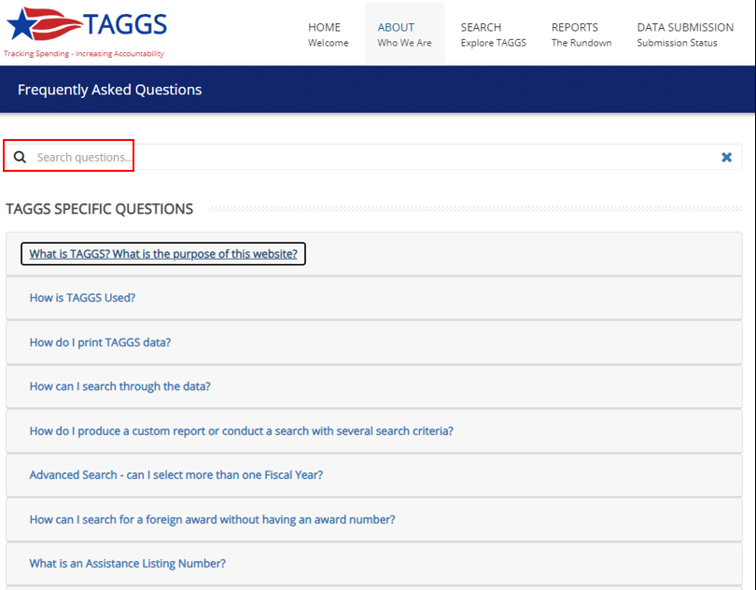

2.4 Site Map

To learn how the pages on TAGGS are organized, navigate to the “Sitemap” under the “About” tab: https://taggs.hhs.gov/About/Sitemap.

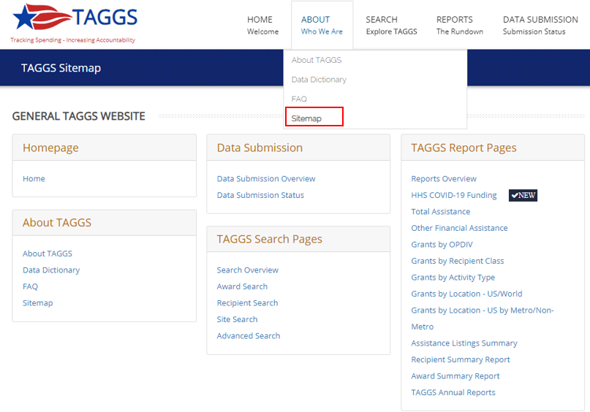

3. Search Capabilities

3.1 Search Overview

Navigate to either the center of the homepage or the top right corner under “Search” to find the Search pages, including “Award Search,” “Recipient Search,” “Site Search,” and “Advanced Search.”

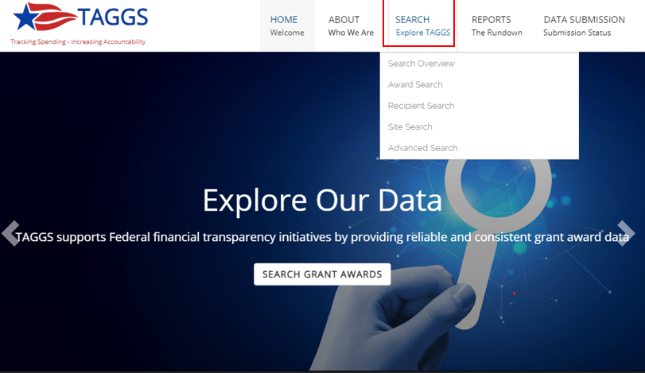
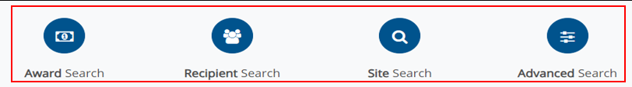

Navigate to the “Search Overview” under the “Search” tab for an explanation of the distinction between the different search engines: https://taggs.hhs.gov/Overview/Search.

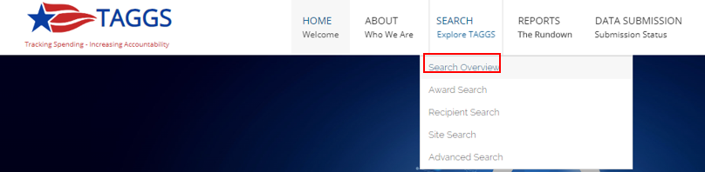

You may navigate directly to the desired search page using “Explore >>.”

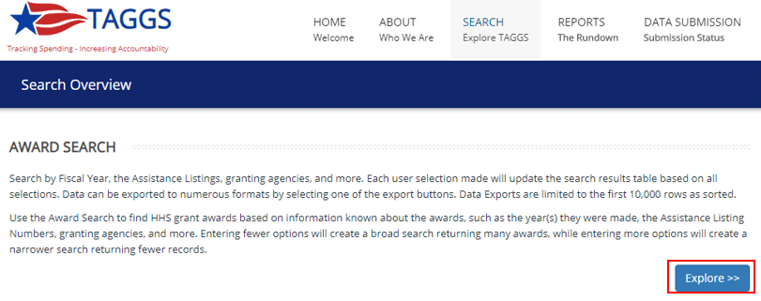

3.2 Award Search

Navigate to Award Search page from either the “Search” toolbar or from the middle of the homepage to access award information: https://taggs.hhs.gov/SearchAward.

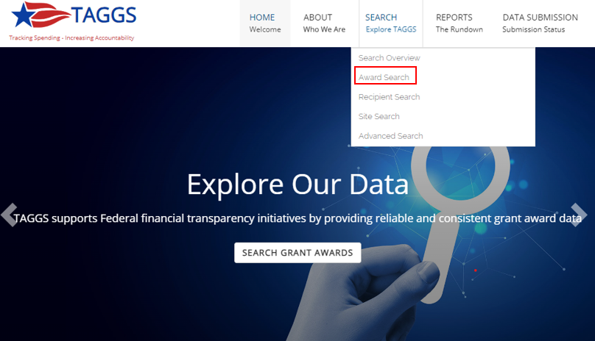
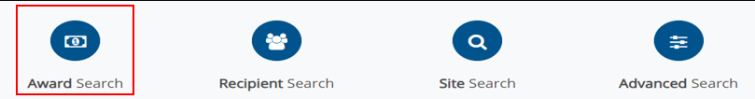
Use the Award Search page to generate a report based on one or more of the following criteria:
- Keyword Search/Award Number
- Issue Date Fiscal Year (FY)
- Funding FY
- Operating Divisions (OpDivs)
- Award Class Type
- Assistance Listing
- State

Input the search criteria on the left-hand side of the page, and then select “Search” to generate the report.

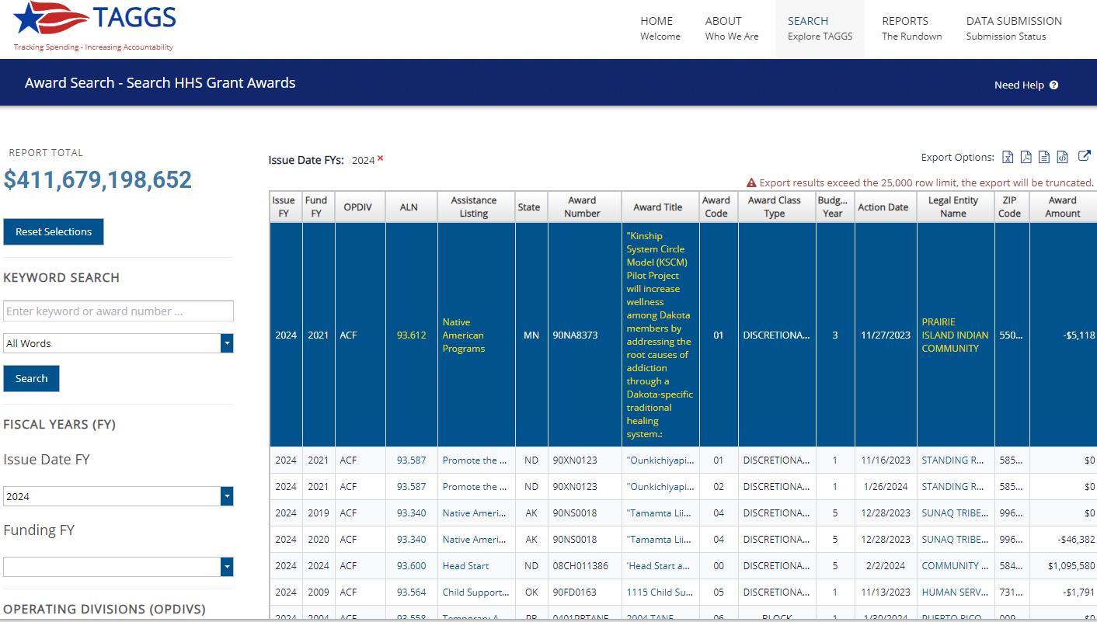

To export the report, select one of the following export options on the top right of the page:
- Microsoft Excel (XLS) file
- Adobe Acrobat (PDF) file
- Microsoft Word (RTF) file
- Comma Separated Values (CSV) file
- Shareable URL

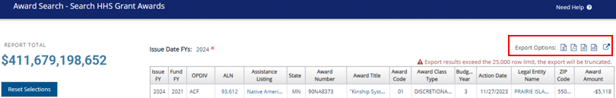

Additionally, please note that exports are limited to 25,000 records. Large queries will be visible in the interface, but the exports will be truncated after 25,000 rows. This limitation applies universally to all exports. To address this constraint, it is advisable to refine the search criteria or narrow down the results individually by FY, when dealing with large exports.

To view additional information about a particular Assistance Listing Number (ALN), Assistance Listing, Award Title, or Legal Entity Name, click the hyperlinks in the search results.

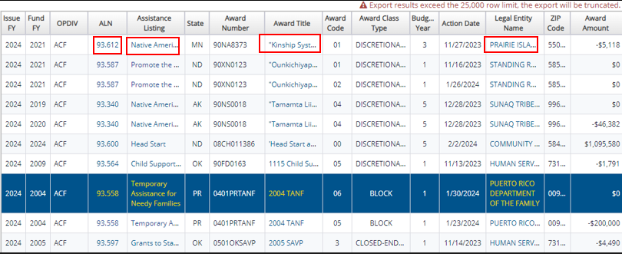

Navigate to the Award Title link to access the Award Detail page, containing comprehensive financial action data throughout the award’s lifespan, along with the award abstract, if provided. Similarly, the ALN and Assistance Listing links lead to the Assistance Detail page, offering a detailed list of all awards associated with the Assistance Listing. Finally, click on the Legal Entity Name to open the Recipient Information page, which provides a list of all awards received by the recipient from HHS.

3.3 Recipient Search

Navigate to Recipient Search page from either the “Search” toolbar or from the middle of the homepage to retrieve award recipient information: https://taggs.hhs.gov/SearchRecip.

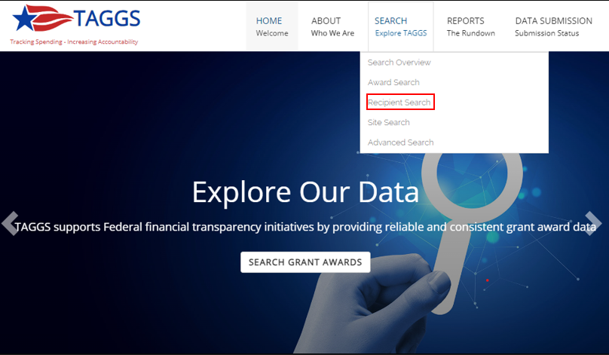

Use the Recipient Search page to generate a report based on one or more of the following criteria:
- Recipient Name
- Unique Entity Identifier (UEI)
- Issue Date FY
- Recipient Class
- Recipient Type
- State

Input the search criteria on the left-hand side of the page, and then select “Search” to generate the report.

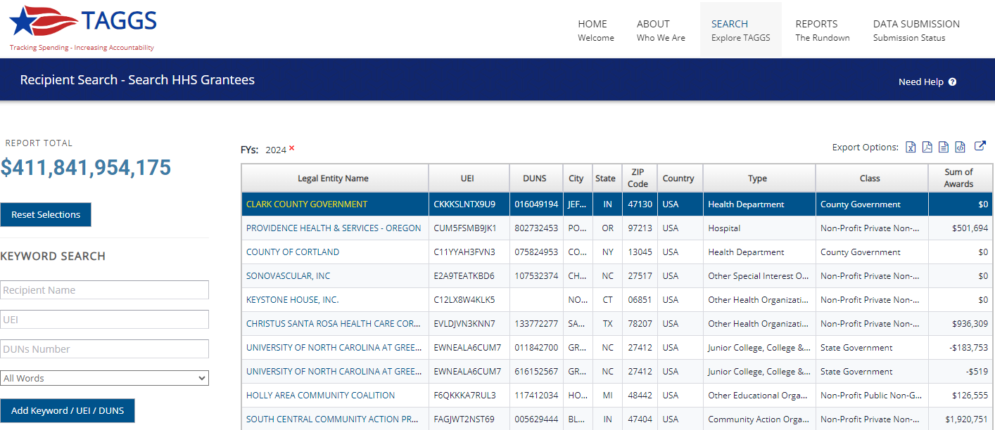

If you have incomplete information about a particular recipient, use the search options “All Words,” “Any Words,” and “Exact Phrase” to help find the results more effectively.

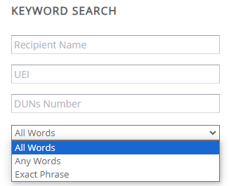

To export the report, select one of the following export options on the top right of the page:
- Microsoft Excel (XLS) file
- Adobe Acrobat (PDF) file
- Microsoft Word (RTF) file
- Comma Separated Values (CSV) file
- Shareable URL

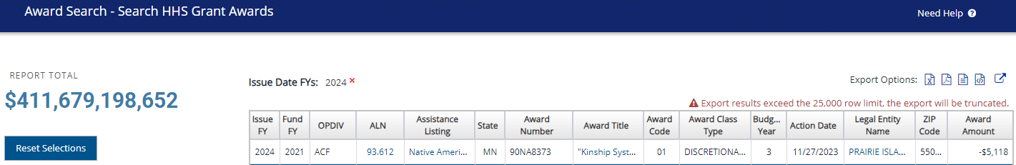

Additionally, please note that exports are limited to 25,000 records. Large queries will be visible in the interface, but the exports will be truncated after 25,000 rows. This limitation applies universally to all exports. To address this constraint, it is advisable to refine the search criteria or narrow down the results individually by FY, when dealing with large exports.

3.4 Site Search

Navigate to the Site Search page from either the “Search” toolbar or from the middle of the homepage to locate a particularly challenging award or recipient using keywords: https://taggs.hhs.gov/SearchSite.

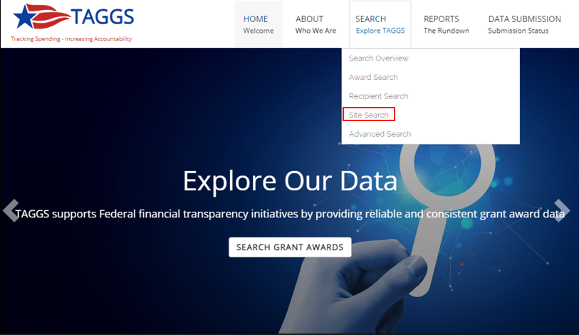
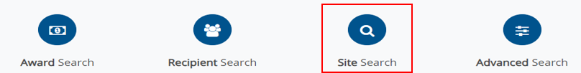
The Site Search functions as a “needle in the haystack” search, enabling users to look up a specific award, recipient name, or keyword using three different matching parameters, outlined below.

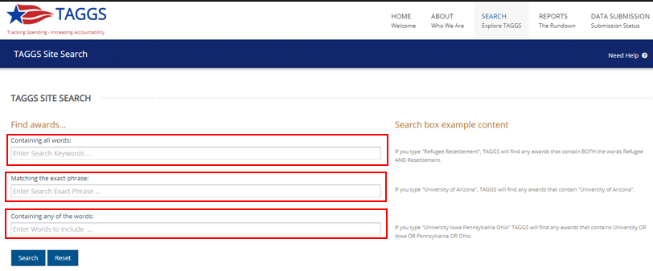

For example, entering “Johns Hopkins University” into the “Containing all words” field will retrieve all award entries containing the words “Johns,” “Hopkins,” and “University” somewhere within the project abstracts.

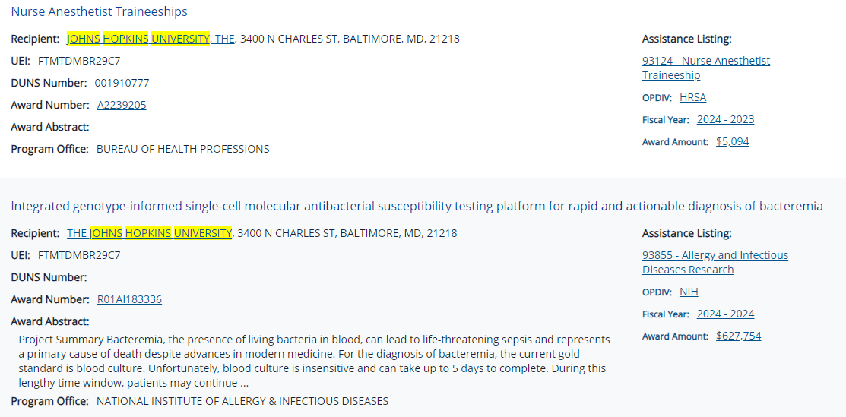

Select the award title hyperlink, and the page will redirect where the abstract is located.

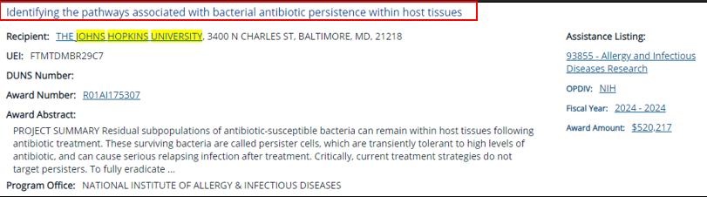

To view the abstract, select “View Award Abstract.”

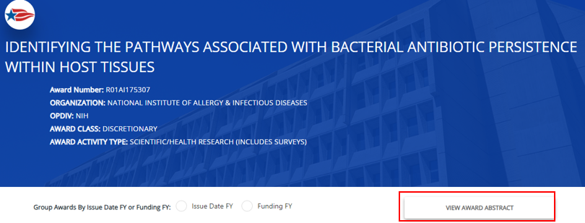

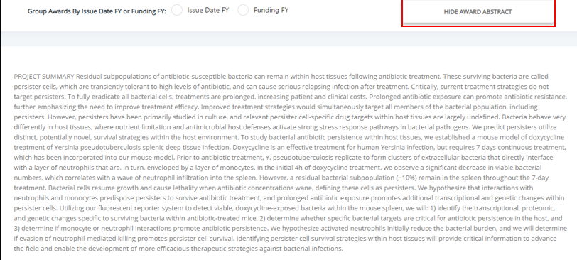

Continuing with the example, use the same phrase, “Johns Hopkins University,” and insert into the “Matching the exact phrase” field. The results will return only those searches where the exact phrase is found in the order it was input in either the award titles or abstracts.

When using the “Containing any of the words” search option, you’ll receive results that include “Johns,” “Hopkins,” or “University.” Furthermore, when utilizing any of these search options, you’ll also have the ability to exclude specific words to help refine your search further.

For instance, if the main focus remains “Johns Hopkins University”, but you’re interested in awards unrelated to medicine or health, you can specify those terms in the “Excluding words” field. Moreover, to narrow down awards from Johns Hopkins University related to business, the query could be structured as follows:

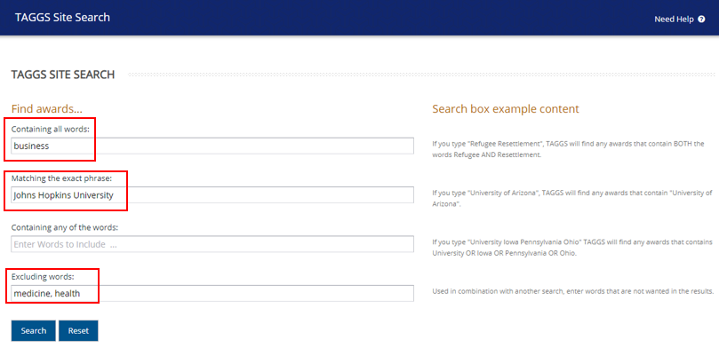

It is advisable to utilize multiple fields together for a more refined search. Providing detailed information will greatly assist in narrowing down the award search effectively.

3.5 Advanced Search

Navigate to Advanced Search page from either the “Search” toolbar or from the middle of the homepage to create a customized report: https://taggs.hhs.gov/SearchAdv.

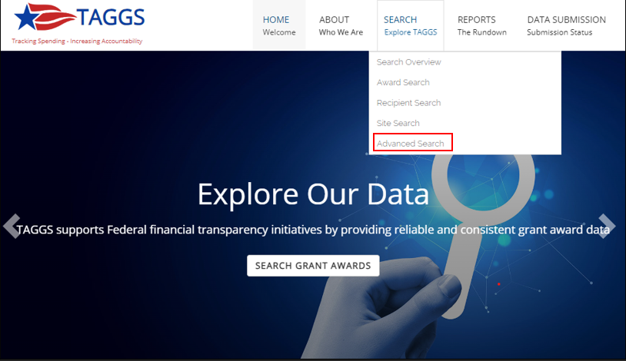

Adjust the following options to generate a custom report:
- Date search
- Text & keyword search
- Program search by OpDiv and assistance listings
- Award search options
- Legal entity search options

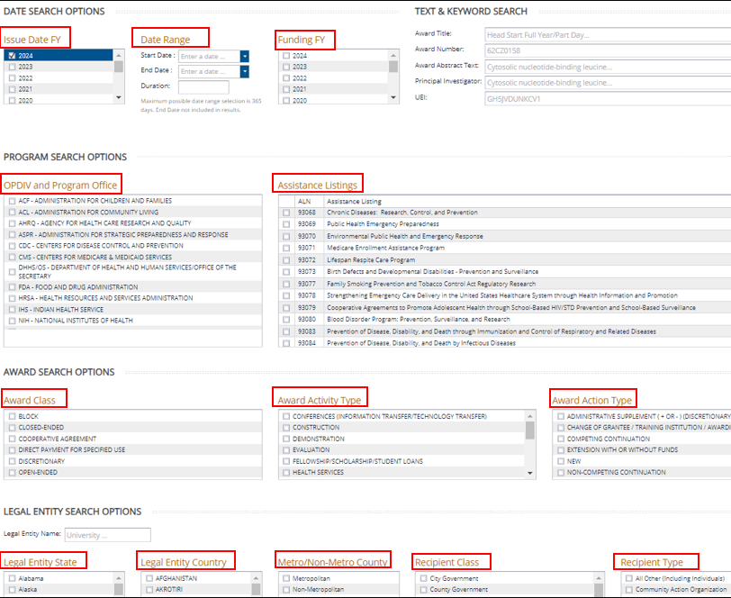

At the bottom of the page, select which columns to include in the generated report, select “Search,” and the page will redirect to a report view. Automatic pre-selections are already set for the following fields:
- Issue Date Fiscal Year
- OpDiv
- Legal Entity Name
- Legal Entity State
- Award Number
- Award Title
- ALN
- Assistance Listing Title
- UEI

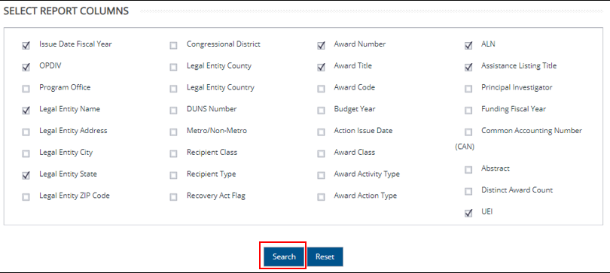

A helpful strategy is to select fewer columns, enabling results to be grouped together in a summary report. For instance, choosing only the Assistance Listing column will create a funding report categorized by Assistance Listing. Similarly, selecting only the OpDiv column will generate a summary report of funding by OpDiv. Note: The negative amounts in the “Sum of Actions” column represent the deobligation of funds.

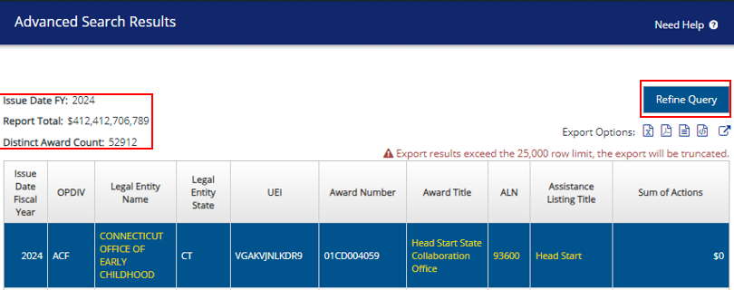

The Report View displays the filters that have been applied to the search in the upper left corner, as well as the total obligation and distinct award count. To refine the search further, the same report may be edited by selecting “Refine Query.”

To export the report, select one of the following export options on the top right of the page:
- Microsoft Excel (XLS) file
- Adobe Acrobat (PDF) file
- Microsoft Word (RTF) file
- Comma Separated Values (CSV) file
- Shareable URL

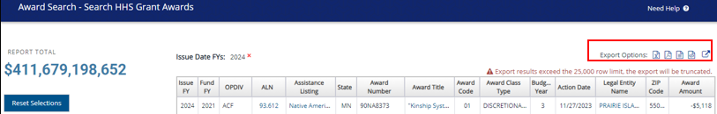

Additionally, please note that exports are limited to 25,000 records. Large queries will be visible in the interface, but the exports will be truncated after 25,000 rows. This limitation applies universally to all exports. To address this constraint, it is advisable to refine the search criteria or narrow down the results individually by FY, when dealing with large exports.

4. Report Capabilities

4.1 Report Overview

Navigate to the top right corner under “Reports” to find various summary reports available through the TAGGS website.

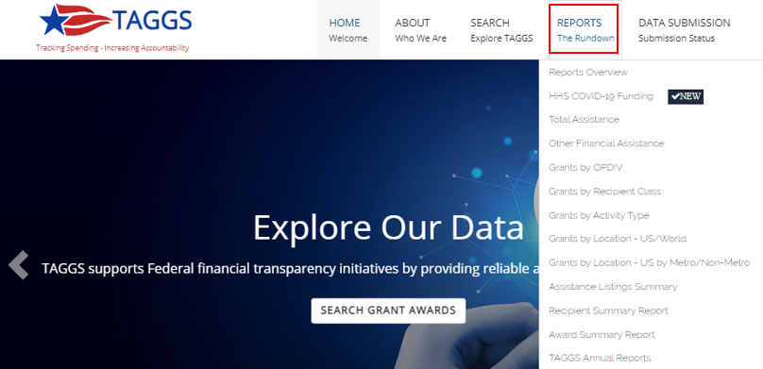
Navigate to the “Reports Overview” under the “Reports” tab for an explanation of the distinction between the different reports: https://taggs.hhs.gov/Overview/Report.

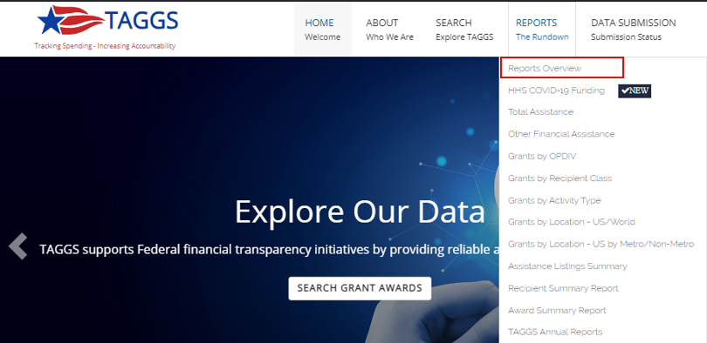

You may navigate directly to the desired reports page using “Explore >>.”

